


Robyn Giles and Jane Preskett
of

444 New Street
BRIGHTON VIC 3186

Telephone: 9596 5787

Prepared by

Andrew Lord B Bus (Acc), Dip FS (Fin Plan)

Level 9, 606 St Kilda Road
Melbourne VIC 3004

Telephone: (03) 9510 0788

Fax: (03) 9510 0799

Email: andrewl@lakesideconsultants.com.au

Authorised Representative 324798

of

Guardianfp Ltd trading as Guardian Financial Planning
ABN 40 003 677 334 Australian Financial Services Licensee No. 237641
Level 10, 321 Kent Street, Sydney, NSW, 2000
Phone: 1300 720 350 Fax: 02 8275 3232 E-mail: enquiries@guardianfp.com.au

13th December 2010 

What this document is about
This Statement of Advice (or SoA) is an important document.
- It provides you with information about our advice so you can make a decision about implementing the advice.
- It should be read in conjunction with other documents such as Product Disclosure Statements and our Financial Services Guide.

What to do after reading this Statement of Advice
Please contact us.
- If you have any questions.
- If we have omitted, overlooked or incorrectly understood any of your relevant circumstances.
- When you are ready to implement the recommendations.
- Or, if you decide you want to do something else and need our advice or assistance.

13 December 2010

Ms Robyn Giles and Ms Jane Preskett
444 New Street
BRIGHTON VIC 3186

Dear Robyn and Jane,

I am pleased to enclose your Statement of Advice (SoA).

It is an important document that you should read and understand before making a decision to proceed further.

We have based the strategies and recommendations in this document on our understanding of your current personal and financial position. If any of this information does not reflect any part of your current position, goals and objectives please advise us immediately and we will make the necessary changes.

The SoA sets out our recommended strategies to address your needs, together with a recommended course of action to implement these strategies.

When you are ready to proceed, we would be very happy to help you with the implementation of the advice, including the completion and lodgement of application forms and other documents.

Please note, our recommendations in this Statement of Advice are valid for 30 days from the date on the cover of this document. If your circumstances change before you implement our recommendations, or if you don’t act on them within 30 days, they may no longer be appropriate for you. If that happens, please ask us to review your situation again before you take any action.

Once implemented, we should review your situation on a regular basis to ensure we make the most of any changes that may impact on the strategies I have recommended for you.

Yours sincerely,

Andrew Lord

B Bus (Acc), Dip FS (Fin Plan)
Authorised Representative No.324798 of
Guardianfp Ltd trading as Guardian Financial Planning

Table of Contents
Purpose of this document 4
Timeframe for our advice 4
Check for accuracy 4
Limitations of our advice 4
Thank you for choosing Guardian Financial Planning 5
Product selection 5
Introduction 6
The Scope of Our Advice 6
Our Investment Recommendations 6
Your Adviser 7
The Planning Process 7
Executive Summary 8
Your Goals and Objectives 8
Recommendation Overview 8
Anticipated Outcomes 9
Future Strategies 9
Personal Information 10
Personal Details 10
Health Details 10
Employment Details 10
Estate Planning 10
Assets and Liabilities 11
Current Risk Management Policies 12
Income and Expenses 13
Your Investor Risk Profile 14
Strategy Recommendation 15
Retirement Planning 15
Superannuation Funds 16
Transition to Retirement 17
Pre-Retirement Income Stream 17
Superannuation Contribution Limits 19
Salary Sacrifice to Superannuation 20
Reversionary Pensions 23
Investment Recommendations 24
Current Portfolio 24
Proposed Portfolio 25
Projected Portfolio Profile Compared to Benchmark 27
Replacement of an Existing Product 32
Cash Flow Projections Post Recommendation 33
What is paid to your adviser 35
Plan Fee 35
Upfront and Ongoing Fee Disclosure 35
Disclosure Statement 37
Summary 40
Appendix – Assumptions 42
Authority to Proceed 43

Purpose of this document

The following Statement of Advice (SoA) is an outline of the financial plan discussed with your financial planner. It details the recommendations needed to execute your plan and achieve your financial objectives.

Timeframe for our advice

Our recommendations in this SoA are valid for 30 days from the preparation date on the cover of this document. If your circumstances change before you implement our recommendations, or if you don’t act on them within 30 days, they may no longer be appropriate for you. If that happens, please ask us to review your situation before taking any action.

Check for accuracy

This SoA is based on the information you provided. Please read the document carefully, checking that your details are correct and that no important facts are missing. If anything is wrong or missing, please let us know immediately—otherwise our advice may be based on incorrect information and may not be right for you.

Limitations of our advice

We cannot give advice on:
- Trust or business structures | - Direct share or property purchases
- Taxation | - Legal matters
- General insurance

Please don’t consider any of this document’s recommendations to be advice in any of these areas. If you need advice in these areas, please see a qualified professional in that field.
Assumptions we've made

When giving advice, we make certain assumptions to demonstrate how the advice could affect your financial situation. We've based our advice on economic information and legislation that was current when we prepared your SoA.

All dollar amounts in this SoA are in today’s dollars, even when we mention future income, expenses, investment amounts and so on. Naturally we can’t predict what future inflation rates will be, so we can only make assumptions based on past trends. Also, all amounts listed in this document are “p.a.” (per annum) unless otherwise stated or implied.

Thank you for choosing Guardian Financial Planning
Guardian Financial Planning is owned by Asteron Limited ABN 94 000 015 949 and is part of the Asteron group of companies which comprises: Asteron Portfolio Services Limited, Asteron Life Limited, Tyndall Investment Management Limited, Tyndall Asset Management Limited, Asteron Advisory Services Limited, Standard Pacific Consulting Limited and Standard Pacific Accounting Ltd. The Asteron Group of companies is ultimately owned by Suncorp-Metway Limited ABN 66 010 831 722 (“Suncorp”). Suncorp is listed on the Australian Stock Exchange. The different entities of the Suncorp Group are not responsible for or liable in respect of products or services provided by other entities of the Suncorp Group.

Some of the products and services we may deal in and advise on your behalf are provided by other Suncorp companies. These companies are listed in the section headed ‘Who owns Guardian Financial Planning’ in the copy of the Financial Services Guide we gave you. This document also outlines who your Authorised Representative is and their contact details in the section headed ‘Before you get advice – Who is my adviser?’ Please ask if you’d like another copy free of charge.

Product selection

We are committed to giving you the best products for your situation. When preparing your advice we considered and recommended only those products on Guardian Financial Planning’s “Approved Product List”. This list was compiled by a dedicated Investment Review Committee, which regularly reviews it. To see the complete product list, please ask us.

Introduction

You are entitled to receive a Statement of Advice (SoA) whenever we provide you with any personal financial advice. Personal financial advice is advice that takes into account any one or more of your objectives, financial situation and needs.

This SoA is a record of the personal financial advice provided to you and includes information on the basis on which this advice is given, information about remuneration including fees, commissions, any other benefits and any interests, relationships or associations which might influence the making of the advice.

If this advice includes a recommendation to you to acquire a particular financial product (other than securities) or an offer to issue or arrange the issue of a financial product to you, we will also provide you with a Product Disclosure Statement containing information about the particular product to help you make an informed decision about that product.

The Scope of Our Advice

Your instructions to us have not placed any limitations on the extent of our advice. You wish for us to review your entire financial position.

In this statement of advice, the main focus is on:
- Wealth creation strategies.
- Cash flow management.
- Tax effective investing.
- Superannuation.

This advice is based on information we have obtained from you. You must ensure the information is accurate and complete. Otherwise, this advice may be based on inaccurate or incomplete information relating to your investment objectives, financial situation or needs. You must therefore assess whether the advice is appropriate, in the light of your own individual investment objectives, financial situation or needs.

You recognise in each of the areas of advice we provide, we only provide advice to the extent we are able to under the relevant legislation.

Our Investment Recommendations

In respect of the specific investments we recommend as part of our advice you are entitled to a 14 day cooling off period for your initial investment. A cooling off period generally means a period of time after which you have provided your capital for investment, where you can change your mind and request for your capital to be returned to you.

Each fund manager or investment provider may implement the cooling off period in a slightly different manner. Therefore we recommend you refer to the Product Disclosure Statement for each of the recommended investments in order to understand the operation of each provider’s cooling off period.

Your Adviser

At any time should you have any questions or concerns, in the first instance please contact your adviser Andrew Lord on (03) 9510 0788.

Andrew Lord is authorised to represent Guardianfp Limited. Should you wish to discuss matters of concern about your adviser or the advice you have received please contact our Compliance Officer on 1800 687 620.

The Planning Process

Robyn and Jane, Financial Planning is a process to help you reach both your Personal and Financial Goals and Objectives. In order to achieve this we jointly need to undertake a number of tasks, including:

- Confirm your personal goals and lifestyle objectives;
- Quantify the resources required to meet your goals and objectives;
- Identify any gaps in your current plans and your stated goals and objectives;
- Develop suitable strategies to address any differences that may exist bearing in mind your attitude to investing and your risk profile;
- Conduct a regular review of the strategies we put into effect to ensure they keep pace with your changing needs, legislative changes and the investment environment.

Executive Summary

In this plan our advice considers the following areas of your financial circumstances.

Your Goals and Objectives

After our discussions I have listed below what we agreed were your key goals and objectives. The points listed below form the basis of the plan I have prepared, and therefore you should read them carefully now to ensure that we have an accurate foundation on which to proceed. If there are any modifications required, please advise us prior to the commencement of your financial plan.

Your goals and objectives are to:
- Focus on wealth accumulation strategies that may potentially help you achieve your capital requirements and lifestyle goals.
- Take advantage of current superannuation legislation especially tax free income from age 60, and therefore seek advice on ways to transition moneys from outside superannuation into the super environment.
- Review your superannuation contribution strategies with the aim of increasing your retirement savings in a tax effective manner.
- Review your superannuation portfolio.
- Minimise your tax commitments.

Recommendation Overview
Considering your stated goals and objectives, investor risk profile and age we recommend that you:
- Jane, split the maximum superannuation contributions for the 2009/2010 financial year to Robyn’s account – continue to do so for the 2011/2012 financial year.
- Jane, rollover your existing IOOF Portfolio Super fund into the recommended wholesale super platform.
- Robyn, rollover your existing Colonial Wholesale superannuation fund into the recommended wholesale pension platform.
- Robyn, commence a Colonial Retail Super Fund.
- Invest your funds in a diverse mix of funds that are in line with your Growth investor risk profile.
- Robyn, you are currently salary sacrificing $5,935 per annum to your Colonial fund – continue to do this to the recommended retail platform.
- Robyn, salary sacrifice an additional $10,500 ($1,750 per month) to the recommended superannuation platform for the remaining 6 months of the 2010/2011 financial year.
- Robyn, salary sacrifice an additional $23,500 ($1,958 per month) to the recommended superannuation platform for 2011/2012 financial year.
- Jane, salary sacrifice $3,000 ($500 per month) to the recommended superannuation platform for the remaining 6 months of the 2010/2011 financial year.
- Jane, salary sacrifice $6,000 ($500 per month) to the recommended superannuation platform for the 2011/2012 financial year.
- Robyn, commence a Reversionary Non-commutable Pre-retirement Wholesale Allocated Pension with $221,146 of your benefits rolled over from your Colonial Super fund.
- Robyn, commence a monthly pension of $1,842 per month.

Anticipated Outcomes
Following our recommendations, we anticipate that:
- Your cash flow surplus of approximately $15,000 per annum will be maintained.
- Robyn’s income tax liability we estimate will be reduced by $1,444 for the 2010/2011 financial year and $3,851 for the 2011/2012 financial year.
- Jane’s income tax liability we estimate will be reduced by $1,155 for the 2010/2011 financial year and $2,310 for the 2011/2012 financial year.
- Your capital is invested inside the superannuation environment consistent with your Growth investor risk profile.
- Jane, by moving to the recommended wholesale platform you will have a cost saving on fees, and improved reporting as well as access to a range of investments that meet your investor risk profile.
- Robyn, you have increased your superannuation contributions by $10,500 in the 2010/2011 financial year and $23,500 in the 2011/2012 financial year.
- Jane, you have increased your superannuation contributions by $3,000 in the 2010/2011 financial year and $6,000 in the 2011/12 financial year.
- Robyn, any future earnings within your pension superannuation fund will be tax free.
- You have re-structured your superannuation assets and increased the tax effectiveness of your retirement benefits upon commencement of an income stream.

Future Strategies

- To annually review superannuation contributions, investment performance and cash flow requirements. We will aim to meet in May/June each year to review.
- Look to increase superannuation contributions. You currently are saving towards purchasing a new car, a potential holiday and Christmas this year.
- Closer to retirement we will provide you with recommendations and advice relating to the retirement stage of your financial plan.

Personal Information

During our discussions and from the information you have provided, your Personal Details can be summarised as follows:

Personal Details
Title | Ms | Ms
First Name | Robyn | Jane
Surname | Giles | Preskett
Gender | F | F
Date of Birth | 29/12/1955 | 05/03/1961
Age Last Birthday | 54 | 49
Marital Status | DeFacto | DeFacto

Health Details
Health Status | Good | Good
Smoking Status | No | No

Employment Details
Employment Status | Full Time | Full Time
Occupation | HR Manager | Head of School
Employer |  | Kingswood College
Proposed Retirement Age | 65 | 65

Estate Planning
 |  | Robyn |  | Jane
Do you have a Current Will? |  | Yes |  | Yes
Do you have Current Powers of Attorney? |  | Yes |  | Yes
Do you have a Testamentary Trust? |  | No |  | No

Assets and Liabilities

The following is an Asset and Liabilities summary that estimates your Net Worth position based on the information provided.

ASSETS
Lifestyle Assets | Value
Residential Home | $800,000
Cash | $2,000
Motor Vehicles | $12,000
Total Lifestyle Assets | $814,000

Superannuation Assets
Robyn
Colonial FirstChoice Wholesale Personal Super | $221,146
Jane
IOOF Portfolio Super fund | $118,136
Total Superannuation Assets | $339,282

Total ASSETS | $1,153,282

LIABILITIES
Personal Loans
Residential Home | $331,000
Total Personal Loans

Total LIABILITIES | $331,000

NET WORTH | $822,282

Notes: As the above information has been used in preparing our recommendations please advise us of any errors or omissions.

The ‘Total’ column indicates the value of assets and liabilities which are owned by the client and partner. This report does not show the value of any portion of the asset or liability that may be owned by a third party or associated entity.

Current Risk Management Policies

Life Insured: Ms Robyn Giles
Product: Underwriter | Policy Owner | Death | TPD | Trauma | Income Protection  Per month | Annual Premium
Prefsure | Robyn | - | - | - | *$4,851 | $2,765
Prefsure | Super | $351,775 | - | - | - | $1,038
Total Sums Insured |  | $351,775 | - | - | $4,851 | $3,803

* Cover paid to age 65 against illness and injury after a 2 year waiting period.

Life Insured: Ms Jane Preskett
Product: Underwriter | Policy Owner |  | Death |  | TPD | Trauma | Income Protection  Per month | Annual Premium
Prefsure | Jane |  | - |  | - | - | ** $4,599 | $2,765
Prefsure | Super |  | $536,038 |  | - | - | - | $841
Prefsure | Jane |  | - |  | - | - | **$1,317 | $1,264
Total Sums Insured |  | $536,038 |  | - |  | - | $5,916 | $4,870

** Cover to age 65 against illness and injury after a 30 waiting period.

Income and Expenses

The following is a summary of your Income and Expenses that estimates your overall Cash Flow position based on the information provided.

Current Estimated Tax Liability for Robyn

Income Source |  | Amount Received | Deduction | Taxable Income | Tax
Salary |  | $100,673
Deductions
Salary Sacrifice |  |  | $5,935
TAXABLE INCOME |  |  |  | $94,738
TAX PAYABLE |  |  |  |  | $23,003
Medicare Levy |  |  |  |  | $1,421
NET TAX |  |  |  |  | $24,424

Current Estimated Tax Liability for Jane

Income Source |  | Amount Received | Deduction | Taxable Income | Tax
Salary |  | $90,056
TAXABLE INCOME |  |  |  | $90,056
TAX PAYABLE |  |  |  |  | $21,271
Medicare Levy |  |  |  |  | $1,351
NET TAX |  |  |  |  | $22,622

Current Estimated Cash Flow
Based on your stated income, expenses and current tax position we estimate your cash flow over one whole financial year to be as follows.

 | Robyn | Jane | Total
Income
Salary | $100,673 | $90,056 | $190,729
Sub Total | $100,673 | $90,056 | $190,729
Less Income Tax | $24,424 | $22,622 | $47,046
Less Superannuation contributions | $5,935 | $0 | $5,935
Net Income | $70,314 | $67,434 | $137,748
Less additional mortgage payments | $19,200 | $19,200 | $38,400
Less budgeted expenditure | $43,614 | $40,734 | $84,348
Income Surplus | $7,500 | $7,500 | $15,000

You have provided us with the above information and advised us that you have a combined surplus income of $15,000 per annum. We have therefore used these figures in the above tables.

Your Investor Risk Profile

The following section of your plan helps to ensure that I clearly understand your attitude to investment selection. Additionally, investments contain various characteristics, which may or may not suit each individual investor.

Based upon your responses to the Risk Profile Questionnaire, it was determined you both have a Growth investor risk profiles.

Typically, a Growth investor has the following characteristics:

- A Growth investor places greater emphasis on capital appreciation with current income and asset preservation being of a secondary concern.
- This requires an investments time horizon of between 5 – 7 years.
- Their portfolio would typically comprise an overweight holding in shares and property with a small exposure to income bearing securities such as cash and fixed interest.

A Growth investor will typically diversify their investment in the following manner:

Australian Shares 45%
International Shares 31%
Fixed Interest 12%
Property 10%
Cash 2%

Our research indicates that long term returns will be best achieved through a diversified portfolio covering all major asset classes (i.e. Cash, Fixed Interest, Shares and Property).

By covering all primary investment markets the risks and volatility of your investments can be managed to levels consistent with your investment profile, whilst maintaining the potential for long term growth.

If you feel the above investor profiles do not reflect your attitude as an investor, or the recommended portfolio contained in this report is too aggressive or conservative, please let me know so I may adjust my recommendations accordingly.

Our recommendation has been made given your risk tolerance, while in balance with your goals and objectives.

Strategy Recommendation

Retirement Planning

Robyn and Jane, you have stated you both wish to retire at age 65.

As you have not provided us with a required retirement income amount, we have based our projections on the industry general rule of thumb, that you will require approximately 75% of your combined current net salary in retirement. That being $100,000 per annum or $50,000 per annum each.

- Robyn, to achieve a retirement income of $50,000 per annum we estimate you will need around $683,319 in initial retirement capital at age 65.
- Jane, to achieve a retirement income of $50,000 per annum we estimate you will need around $683,319 in initial retirement capital at age 65.
- We estimate that by the time that you are both 65 you will have a combined accumulated retirement capital balance of around $827,364.
- To achieve a retirement income of $100,000 per annum we estimate you will need around $1,366,638 in combined initial retirement capital at age 65.
- Based on these figures you currently have a combined retirement capital surplus of an estimated $539,274.
- You will need to consider additional wealth accumulation strategies such as salary sacrifice, gearing strategies, etc to help you achieve your capital goal. We will provide ongoing advice to help you achieve this.
- Robyn, for example to achieve $683,319 in initial retirement capital at age 65 we estimate you will need to contribute an extra $1,648 per month ($19,776 per annum) into your superannuation.
- Jane, for example to achieve $683,319 in initial retirement capital at age 65 we estimate you will need to contribute an extra $1,622 per month ($19,464 per annum) into your superannuation.

Note: The estimated figures above do not include any assets outside of the superannuation environment or any of the new recommended investments

Superannuation Funds

Recommendations:

- Robyn, rollover your existing Colonial Wholesale Super Fund to the recommended wholesale pension fund platform. (See Colonial FirstChoice investment recommendation section below.)
- Robyn, commence a Colonial Retail Super fund and direct all future contributions to this fund.
- Jane, rollover your existing IOOF Portfolio Super fund to the recommended wholesale superannuation fund platform. (See Colonial FirstChoice investment recommendation section below) and direct all future contributions to this fund.
- Robyn and Jane’s portfolios are to be invested according to a sector specific asset allocation that is in line with your investor risk profiles.

Benefits:

- A sector specific asset allocation strategy takes advantage of expert fund managers who specialise in that single sector.
- You will have access to an anti-detriment payment. This is where the contributions tax you pay on monies contributed may be refunded on the death of a member.
- You will have access to a wide range of investment options with access to more than one specialist manager within each asset class.
- Jane, as you have over $100,000 in super you can access a wholesale super fund and therefore a larger pool of invested funds and lower fees than would be applicable to a retail fund.
- The recommended wholesale fund platform has a wide range of investment options with access to more than one specialist manager within each asset class.
- Your benefits will be invested within a range of assets and asset classes giving you a well diversified investment portfolio that aims to generate higher levels of growth over the longer term 7+ years.
- You will gain ongoing advice from us as your financial adviser as we will have full access to information relating to the recommended superannuation fund. This will enable us to provide thorough and timely advice to you.

Risks:

- The recommended investment’s performance is subject to market fluctuations.
- Investment performance is not guaranteed.

Transition to Retirement
The aim of a ‘Transition to Retirement’ strategy is to utilise current legislation to increase superannuation contributions whilst remaining cash flow neutral.
Current legislation allows you (as you have reached preservation age) to commence a non-commutable income stream with your superannuation monies without having to satisfy a condition of release. This income stream is taxable at your marginal rate with a provision for your tax free component and a 15% tax offset applicable to your taxable component. From age 60, all income received from this income stream are tax free. Once you have commenced an income stream all income on the amount funding the income stream is tax free as opposed to being taxed at 15% when in accumulation phase.
The minimum pension amount that you can draw is 2% of your account balance per annum whilst the maximum pension is 10% and is re-calculated in July each year.
The additional income received from your pre-retirement income stream allows you to make additional contributions to superannuation in the form of salary sacrifice. Salary sacrifice contributions are pre-tax contributions and therefore result in a reduction of assessable income. These superannuation contributions are concessionally taxed at a maximum of 15% as opposed to marginal tax rates of up to 46.5%.
The ‘Transition to Retirement’ strategy results in an increased net inflow to superannuation and therefore a maximisation of your retirement savings in a tax effective manner.

Pre-Retirement Income Stream

Recommendations:

Robyn

Stage 1 – January 2011 to June 30th 2011

- Robyn, commence a Reversionary non-commutable allocated pension with $221,146 of your benefits rolled over to the recommended pension platform. (See Colonial Wholesale Pension investment recommendation section.)
- Robyn, commence the maximum pension of $1,842 per month pro-rata.
- This pension income is to be used to supplement your income that you will both salary sacrifice to superannuation.

Stage 2 – 2011 / 2012 Financial Year

- Robyn, continue to receive the nominated amount of $1,842 per month.
- The selected pension amounts may need to be adjusted each year, therefore we will need to discuss this with you in around May – June each year.
Benefits:

- By commencing a pre-retirement income stream you are increasing your income in a tax effective manner and therefore allowing you to commence a salary sacrifice arrangement.
- There is an immediate income tax benefit on withdrawal and re-contribution via salary sacrifice, as a result of this strategy.

- The income from a pre-retirement income stream is tax effective income, in that you will receive such benefits as:
  - A deductible amount for tax purposes – which reduces your taxable income.
  - A 15% income stream tax rebate on all assessable income.

Risks:

- Your income stream capital is subject to market performance fluctuations which may have a flow on effect to your income received.
- A condition of the transition to retirement income stream is that it is non-commutable – no lump sum withdrawals can be made until you satisfy a condition of release.

Superannuation Contribution Limits

Table 1- Concessional contribution limits

Concessional contributions include employer and self employed contributions such as salary sacrifice, superannuation guarantee and personal concessional contributions.

Date | Limit (per annum)
Date | Age 35-49 | Age 50 to 64 | Age 65 to 74* | Age75 and over
From 1 July 2009 | $25,000 | $50,000 | $50,000 | Cannot contribute
From 1 July 2012**  (super balance > $500k) | $25,000 | $25,000 | $25,000 | Cannot contribute
From 1 July 2012**  (super balance < $500k) | $25,000 | $50,000 | $50,000 | Cannot contribute

*Must be employed at least 40 hours during any consecutive 30 day period in the financial year you would like to make the contributions.
Concessional Contributions were previously known as Deductible Contributions (e.g. Salary Sacrifice).

** Subject to legislation being passed.
$50,000 $50,000 $50,000 $25,000/$50,000 $25,000/$50,000

$25,000 $25,000 $25,000 $25,000 $25,000

1/7/09 1/7/10 1/7/11 1/7/12 1/7/13 1/7/14

Under age 50
Aged 50 to 75

Table 2 - Non-concessional contribution limits

Date | Limit on after-tax contributions | Eligibility Requirements
Date | Limit on after-tax contributions | Under age 65 | Age 65 to 74 | Age 75 and over
From  1 July 2007 | $150,000 p.a. | May bring forward two years of contributions to make a $450,000 contribution in one financial year | Must be employed* | Can not contribute
$150,000 $150,000 $150,000 $150,000 $150,000

1/7/07 1/7/08 1/7/09 1/7/10 1/7/11 1/7/12

If over age 65 then must be employed
$450,000 over rolling 3 year period

Salary Sacrifice to Superannuation

Recommendation:

- Robyn, from January 2011, commence an additional salary sacrifice arrangement of $1,750 per month to your Colonial FirstChoice Retail fund for the remainder for the 2010/2011 financial year. This combined with your existing salary sacrifice of $494.58 per month, will result in your total monthly salary sacrifice being $2,244.58 for the remainder of the 2010/2011 financial year.
- From July 2011, change your current salary sacrifice arrangements to $29,435 per annum ($2,452.91 per month) to your Colonial FirstChoice Retail fund.
- Jane, from January 2011, commence a salary sacrifice arrangement of $500 per month to your Colonial FirstChoice Wholesale fund for the remainder of the 2010/2011 financial year.
- From July 2011, continue salary sacrificing $500 per month to your Colonial FirstChoice Wholesale fund for the 2011/2012 financial year.
- Arrange this with both your respective employers as soon as possible.

Benefits:

- Salary sacrifice contributions are made with pre-tax dollars and therefore you will receive a reduction in taxable income for the contributions that you make.
- Robyn and Jane’s salary sacrifice contributions will be taxed at a maximum of 15% compared to the 38.5% if taken as income.
- Robyn’s income tax liability we estimate will be reduced by $1,444 for the 2010/2011 financial year and $3,851 for the 2011/2012 financial year.
- Jane’s income tax liability we estimate will be reduced by $1,155 for the 2010/2011 financial year and $2,310 for the 2011/2012 financial year.

Risks:

- Superannuation benefits are subject to market returns and earning rates are not guaranteed.

IMPORTANT:
It is important that any salary sacrifice arrangement is clearly documented in writing. You should also confirm with your employer that they are going to continue to pay Superannuation Guarantee Contributions (SGC) on the grossed up amount of your package, i.e. that the SGC will continue to be calculated on the total of your salary + salary sacrificed amount.

Robyn:

2010/11 FINANCIAL YEAR:
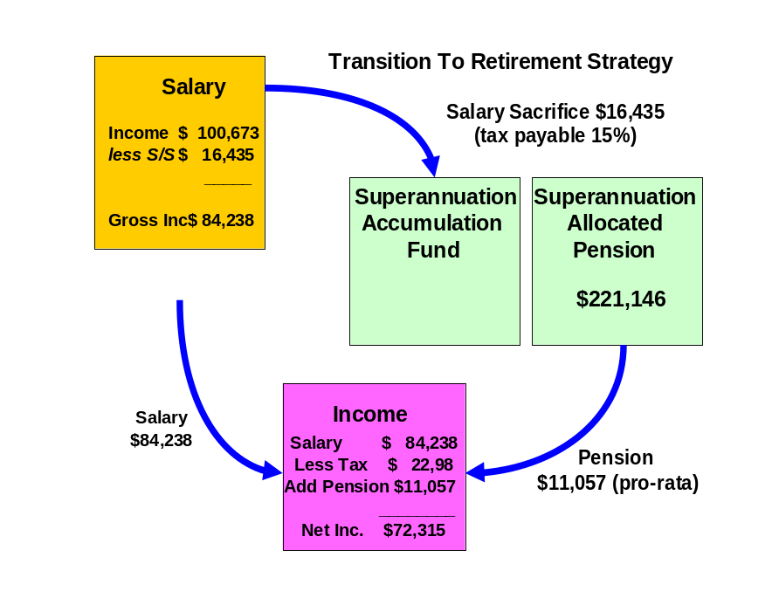

2011/12 FINANCIAL YEAR:
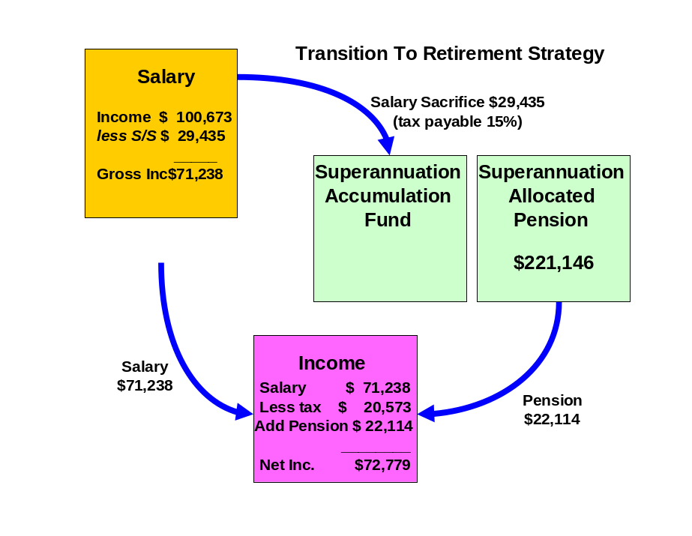

Jane:

2010/11 FINANCIAL YEAR:
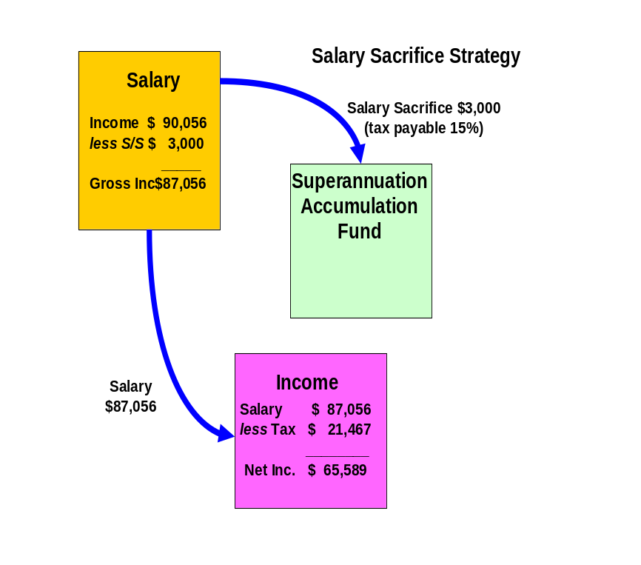

2011/12 FINANCIAL YEAR:
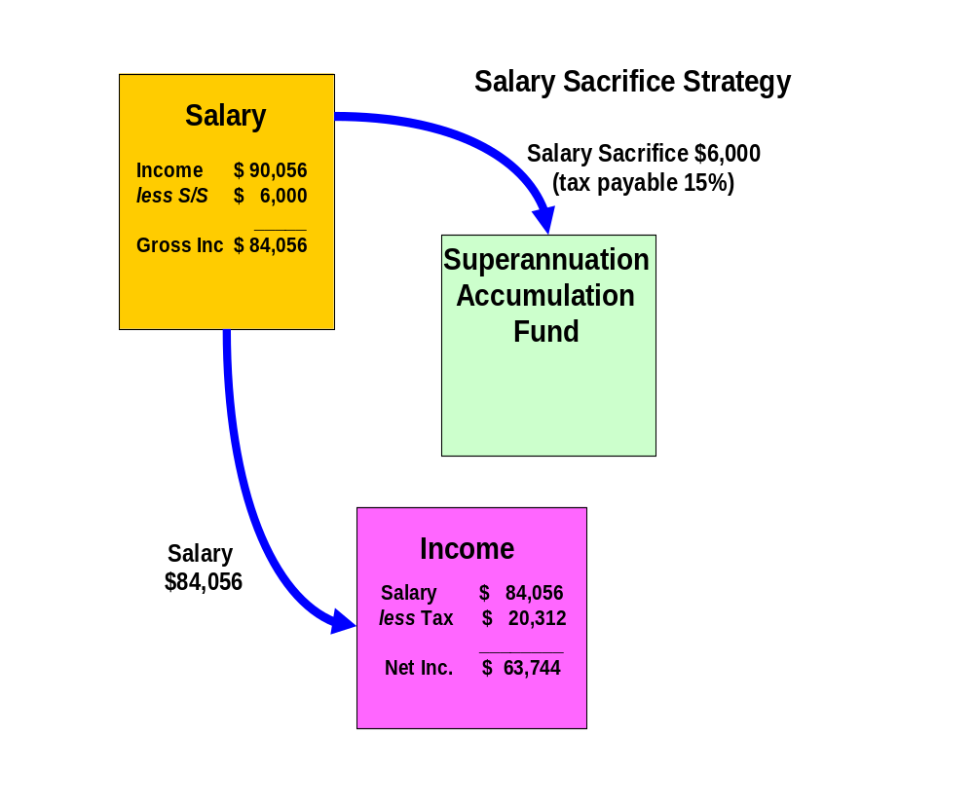

Reversionary Pensions

Recommendations:

Robyn, when you commence your pre-retirement income stream (pension) you should make it reversionary.

Benefits:
- A reversionary pension enables your tax dependant beneficiary to receive your pension account balance remaining within the superannuation environment. All moneys received by the reversionary beneficiary remain in pension phase and therefore all income earned by the fund or capital gains realised by the fund to pay the benefit pension will not be subject to tax.
- If either the deceased or the recipient of the reversionary pension is over the age of 60, the income stream will not be assessable for income tax purposes.
Risks:

- If the income stream is commuted (either rolled into an accumulation fund or lump sums are withdrawn) within six months after the death of the deceased or 3 months after the grant of probate of that deceased person's will or letters of administration of that deceased person's estate, then it is treated as a death benefit payment. Therefore the moneys would be treated as a lump sum benefit outside of the superannuation environment.
- Death benefits in the form of a pension may only be paid to a “Tax Dependant” which will include the deceased members’ spouse, children under the age of 18 and persons financially dependent on the deceased member (and under the age of 25). In other words if the beneficiary did not fit the above description then they could only receive a lump sum and not a pension, thus they would lose the benefits of being in pension phase.
- If both the deceased member and the tax dependant are aged below 60 years then the pension will be included in the tax dependant’s assessable income less a 15% rebate until the tax dependant turns 60 years at which time the pension will be tax free.

Investment Recommendations

After considering your investment profile, your financial objectives, the current economy and economic trends, we recommend that your funds be invested in the following manner.

Current Portfolio
ASSETS
Lifestyle Assets | Value
Residential Home | $800,000
Cash | $2,000
Motor Vehicles | $12,000
Total Lifestyle Assets | $814,000

Superannuation Assets
Robyn
Colonial FirstChoice Wholesale Personal Super | $221,146
Jane
IOOF Portfolio Super fund | $118,136
Total Superannuation Assets | $339,282

Total ASSETS | $1,153,282

LIABILITIES
Personal Loans
Residential Home | $331,000
Total Personal Loans

Total LIABILITIES | $331,000

NET WORTH | $822,282

Proposed Portfolio
ASSETS
Lifestyle Assets | Value
Residential Home | $800,000
Cash | $2,000
Motor Vehicles | $12,000
Total Lifestyle Assets | $814,000

Superannuation Assets
Robyn
Colonial FirstChoice Wholesale Personal Super | $0
Colonial FirstChoice Retail Super* | $0
Colonial FirstChoice Wholesale Pre-Retirment Pension
BT Wholesale Core Australian Share | $29,634
Fidelity Wholesale Australian Equities | $34,499
Perennial Wholesale Value Australian Share | $20,124
Acadian Wholesale Australian Equity | $15,259
BT Core Wholesale Global Share Fund (AQR) | $17,249
Platinum Wholesale International | $11,721
Perpetual Wholesale International Share Fund | $17,249
MFS Wholesale Global Equity | $22,336
BT Wholesale Property Securities | $8,625
RREEF Wholesale Property Securities | $4,202
CFS WS Colliers Global Property Securities | $9,288
FirstChoice Wholesale Fixed Interest | $26,538
CFS Wholesale Cash Fund | $4,423
 | $221,146
Jane
IOOF Portfolio Super fund | $0
Colonial FirstChoice Wholesale Super
BT Wholesale Core Australian Share | $15,830
Fidelity Wholesale Australian Equities | $18,429
Perennial Wholesale Value Australian Share | $10,750
Acadian Wholesale Australian Equity | $8,151
BT Core Wholesale Global Share Fund (AQR) | $9,215
Platinum Wholesale International | $6,261
Perpetual Wholesale International Share Fund | $9,215
MFS Wholesale Global Equity | $11,932
BT Wholesale Property Securities | $4,607
RREEF Wholesale Property Securities | $2,245
CFS WS Colliers Global Property Securities | $4,962
FirstChoice Wholesale Fixed Interest | $14,176
CFS Wholesale Cash Fund | $2,363
 | $118,136
Total Superannuation Assets | $339,282

Total ASSETS | $1,153,282

LIABILITIES
Personal Loans
Residential Home | $331,000
Total Personal Loans

Total LIABILITIES | $331,000

NET WORTH | $822,282
*This will increase over time through proposed salary sacrifice and employer contributions.

Projected Portfolio Profile Compared to Benchmark

Asset Class | Projected Portfolio | Benchmark Profile for Growth | Deviation
Australian Shares | 45% | 45% | 0%
International Shares | 31% | 31% | 0%
Property | 10% | 10% | 0%
Fixed Interest | 12% | 12% | 0%
Cash | 2% | 2% | 0%
Other | 0% | 0% | 0%

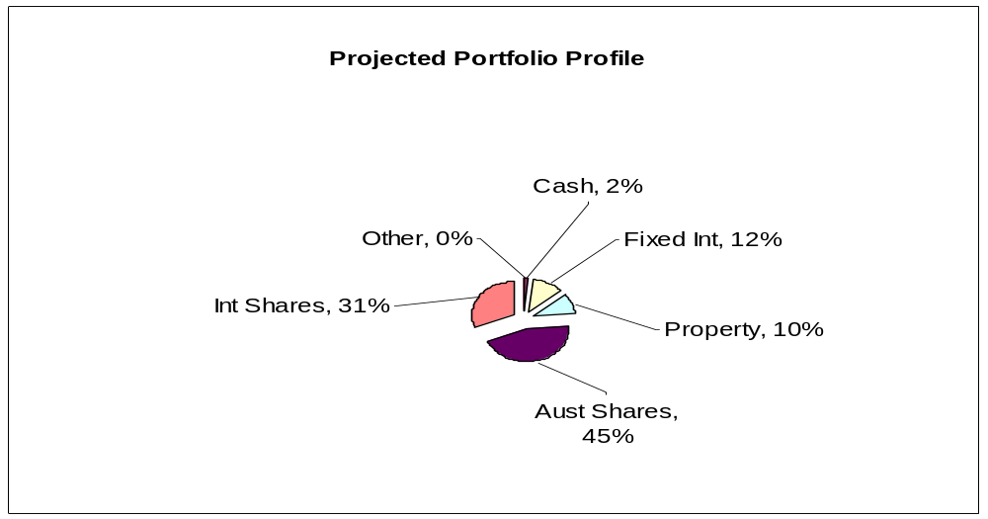

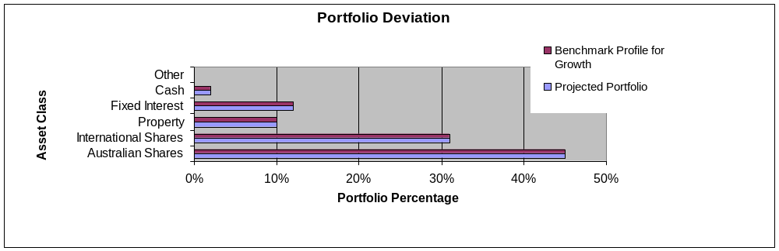

As an industry standard, a variance of 10% within a particular asset class is allowed to cater for individual circumstances, economic events and fund manager asset allocation decisions. Variations outside of this range may be appropriate in certain circumstances.

Colonial FirstChoice Retail Investments
The FirstChoice Investments is a multi-manager investment solution which combines wide investment choice with a competitive and simple fee structure, backed up by a high standard of service support from Colonial First State.

A minimum total investment of $5,000 ($1,500 for super) is required to establish an account in FirstChoice Investments. A $1,000 minimum initial balance is required if a regular investment plan is set up at commencement of the account. The minimum regular investment plan amount is $100 per month.

Reasons and Benefits
The major features of the Colonial FirstChoice Investments are as follows:

Sector Specific Diversification
A strong range of investment options with access to more than one specialist manager within each asset class. This approach captures the competitive advantages of each manager. We anticipate this will provide higher returns than can be obtained from using diversified funds with, say, only one fund manager.

Simplicity
Consolidated reporting from Colonial First State.

Ease of Management
Automatic investment re-balancing and switching to help you easily and conveniently keep your investment strategies on track.

- We recommend that annual automatic rebalancing is elected.

Highly competitive and simple to understand fee structure
- There is a default contribution fee of 4% if you do not have a Financial Adviser. As your Adviser, Lakeside Consultants Pty Ltd will reduce this fee to 0%.
- The management fee for the Geared Colonial FirstChoice Investments Plan varies from 2.60% to 4.06% pa.
- You can agree with your Financial Adviser to have an ongoing Adviser Service Fee for advice paid directly from your investment. The ongoing fee will be deducted monthly from your investment options.
  - Our normal 0.75% p.a. Adviser Service fee will apply.
- No switching fees or exit fees apply to this investment.

Colonial FirstChoice Management Fee
Colonial FirstChoice charges a Management Expense Ratio to cover their administration costs and the associated costs of managing your funds and the advisers trail fee. Based on your current portfolio value, we have provided an estimation of the costs you will pay.

Robyn – Retail Super

Colonial FirstState FirstChoice Investments | MER  % | Amount invested ❶  $ | Estimated  fee  $
BT Core Australian Share | 1.86% | $0 | $0
Fidelity Australian Equities | 1.90% | $0 | $0
Perennial Value Australian Share | 1.86% | $0 | $0
Acadian Australian Equity | 1.92% | $0 | $0
BT Core Global Share Fund (AQR) | 2.00% | $0 | $0
Platinum International | 2.45% | $0 | $0
Perpetual International Share Fund | 2.01% | $0 | $0
MFS Global Equity | 2.00% | $0 | $0
BT Property Securities | 1.65% | $0 | $0
RREEF Property Securities | 1.66% | $0 | $0
CFS Colliers Global Property Securities | 1.85% | $0 | $0
FirstChoice Fixed Interest | 1.50% | $0 | $0
CFS Cash Fund | 1.10% | $0 | $0
Total ongoing fees ❷ | 1.87% | $0 | $0

❶ Colonial FirstChoice’s Management Fee is calculated on the value of your total portfolio. As such we have used the current portfolio to estimate your annual ongoing fee.
- From the Ongoing Management Fee your adviser will receive trail commissions from the fees you pay to Colonial FirstChoice. This ongoing trail will total 0.60% p.a.

Please note that there is an additional adviser service fee of 0.15% that is paid by you.

Additional details of the above fees are outlined in the Colonial’s Product Disclosure Statement.

Colonial FirstChoice Wholesale Investments
The FirstChoice Wholesale Investments is a multi-manager investment solution which combines wide investment choice with a competitive and simple fee structure, backed up by a high standard of service support from Colonial First State.

The minimum initial investment the Colonial FirstChoice Wholesale Investments Plan accepts is $100,000. There is no minimum additional investment amount required, however minimum regular investment and withdrawals are set at $500. Regular payments can also be made by BPay. You can then monitor and manage your investments over the Internet, by phone or through your financial adviser.

Reasons and Benefits
The major features of the Colonial FirstChoice Wholesale Investments are as follows:

Sector Specific Diversification
A strong range of investment options with access to more than one specialist manager within each asset class. This approach captures the competitive advantages of each manager. We anticipate this will provide higher returns than can be obtained from using diversified funds with, say, only one fund manager.

Simplicity
Consolidated reporting from Colonial First State.

Ease of Management
Automatic investment re-balancing and switching to help you easily and conveniently keep your investment strategies on track.
- We recommend that annual automatic rebalancing is elected.

Highly competitive and simple to understand fee structure
- No entry fee applies to this investment however, with your agreement; your Financial Adviser may wish to charge a one off fee to cover upfront costs.
- An ongoing management fee ranging from 0.31% p.a. to 2.96% p.a. applies, depending on investment options chosen. This fee is all inclusive, covering Colonial First State's administration fee and investment management fee. No ongoing remuneration is paid to Guardian Financial Planning out of this fee.
- The weighted average management fee for the Colonial FirstChoice Wholesale Investments Plan is 1.11% for Growth, 1.37 for High Growth and 1.2% for Gearing.
- You can agree with your Financial Adviser to have an ongoing Adviser Service Fee for advice paid directly from your investment. The ongoing fee will be deducted monthly from your investment options.
  - Our normal 0.75% p.a. Adviser Service fee will apply.
- No switching fees or exit fees apply to this investment.
- Within the Wholesale Investment plan a buy-sell spread of between 0 – 0.55% applies depending on investment option. Please refer to the Product Disclosure Statement for details.
Colonial FirstChoice Management Fee
Colonial FirstChoice charges a Management Expense Ratio to cover their administration costs and the associated costs of managing your funds and the advisers trail fee. Based on your current portfolio value, we have provided an estimation of the costs you will pay.

Robyn:
Colonial FirstState FirstChoice Investments - Pension | MER  % | Amount invested   $ | Estimated  fee  $
BT Wholesale Core Australian Share | 1.00% | $29,634 | $296
Fidelity Wholesale Australian Equities | 1.05% | $34,499 | $362
Perennial Wholesale Value Australian Share | 1.00% | $20,124 | $201
Acadian Wholesale Australian Equity | 1.21% | $15,259 | $185
BT Core Wholesale Global Share Fund (AQR) | 1.30% | $17,249 | $224
Platinum Wholesale International | 1.80% | $11,721 | $211
Perpetual Wholesale International Share Fund | 1.35% | $17,249 | $233
MFS Wholesale Global Equity | 1.20% | $22,336 | $268
BT Wholesale Property Securities | 1.05% | $8,625 | $91
RREEF Wholesale Property Securities | 0.80% | $4,202 | $34
CFS WS Colliers Global Property Securities | 1.00% | $9,288 | $93
FirstChoice Wholesale Fixed Interest | 0.75% | $26,538 | $199
CFS Wholesale Cash Fund | 0.40% | $4,423 | $18
Total ongoing fees | 1.09% | $221,146 | $2,414

Jane:
Colonial FirstState FirstChoice Investments - Super | MER  % | Amount invested   $ | Estimated  fee  $
BT Wholesale Core Australian Share | 1.01% | $15,830 | $160
Fidelity Wholesale Australian Equities | 1.05% | $18,429 | $194
Perennial Wholesale Value Australian Share | 1.01% | $10,750 | $109
Acadian Wholesale Australian Equity | 1.21% | $8,151 | $99
BT Core Wholesale Global Share Fund (AQR) | 1.30% | $9,215 | $120
Platinum Wholesale International | 1.80% | $6,261 | $113
Perpetual Wholesale International Share Fund | 1.35% | $9,215 | $124
MFS Wholesale Global Equity | 1.20% | $11,932 | $143
BT Wholesale Property Securities | 1.05% | $4,607 | $48
RREEF Wholesale Property Securities | 0.80% | $2,245 | $18
CFS WS Colliers Global Property Securities | 1.00% | $4,962 | $50
FirstChoice Wholesale Fixed Interest | 0.75% | $14,176 | $106
CFS Wholesale Cash Fund | 0.40% | $2,363 | $9
Total ongoing fees | 1.09% | $118,136 | $1,292

 Colonial FirstChoice’s Management Fee is calculated on the value of your total portfolio. As such we have used you current portfolio to estimate your annual ongoing fee.
Please note that there is an additional adviser service fee of 0.75% that is paid by you.
Additional details of the above fees are outlined in the Colonial’s Product Disclosure Statement.

Replacement of an Existing Product
Jane:

Type of Fee or Cost | IOOF Portfolio Super Fund | Colonial Wholesale Super Fund
Contribution/Entry fee – this is the fee for initial and subsequent contributions. | Nil | Nil
Withdrawal/Exit Fee – this is the fee for each withdrawal you make | Nil | Nil
Switching Fee – fee charged for switching between investment options in the super fund. | Nil | Nil
Administration Costs – are the fees and costs that cover the operation of the fund. They include admin, member and other fees charged by the product issuer | $1,617  (admin fee 1.4% on first $100,000 & 1.2% thereafter) | Nil
Adviser Service Fee – additional fee paid to financial adviser | Nil | 0.75%
Investment Costs - Current – are the fees and costs the product issuer charge for investing the assets. These include fees paid to external fund mgrs. | 0.904% | 1.09%
Annual average cost - Total $118,136 investment | $2,685 | $2,173
Investment Costs –  Relevant to Your Risk Profile | Same as above | Same as above
Annual average cost – Relevant to Your Risk Profile (on same balance as above) | Same as above | Same as above
Amount of Insurance Cover – Life, TPD and Income Protection held inside super | n/a | n/a
Cost of above insurance cover per annum. | n/a | n/a

The investment cost will vary depending on which fund you are invested in, the assets it invests into and how actively they manage their portfolios, amongst other things. Typically these costs should not be compared directly.

Outcomes Post Recommendation:

- The sum of your total ongoing management and administration fees will potentially be reduced resulting in a saving of approximately $512 if your funds were to remain at present.
- You will gain access to a diversified portfolio of funds that matches your investor risk profile and investment objectives.

Cash Flow Projections Post Recommendation
Following the implementation of this strategy and investment recommendations within this report we estimate that your future tax liabilities and cash flows to be as follows.

Estimated Tax Liability for Robyn 2010/11
Income Source |  | Amount Received | Deduction | Taxable Income | Tax
Gross Salary |  | $100,673
Pension Income Stream |  | $11,057
Deductions |  | $111,730
Current Salary Sacrifice to Superannuation |  |  | $5,935
Additional Salary Sacrifice to Superannuation |  |  | $10,500
TAXABLE INCOME |  |  |  | $95,295
Tax payable before rebates/credits |  |  |  |  | $23,209
Medicare Levy |  |  |  |  | $1,429
Net Tax before rebates/credits |  |  |  |  | $24,638
Income Stream Rebate |  |  |  |  | $1,658
NET TAX |  |  |  |  | $22,980

Estimated Tax Liability for Jane 2010/11
Income Source |  | Amount Received | Deduction | Taxable Income | Tax
Gross Salary |  | $90,056
Deductions
Current Salary Sacrifice |  |  | $0
Proposed Salary Sacrifice |  |  | $3,000
TAXABLE INCOME |  |  |  | $87,056
Tax payable before rebates/credits |  |  |  |  | $20,161
Medicare Levy |  |  |  |  | $1,306
Net Tax before rebates/credits |  |  |  |  | $21,467
NET TAX |  |  |  |  | $21,467

Current Estimated Cash Flow 2010/2011
Based on your stated income, expenses and current tax position we estimate your cash flow over one whole financial year to be as follows.
 | Robyn | Jane | Total
Income
Income Received - Salary | $100,673 | $90,056 | $190,729
Income Received - Pension | $11,057 | $0 | $11,057
Sub Total | $111,730 | $90,056 | $201,786
Less Income Tax | $22,980 | $21,467 | $44,447
Less Current Salary Sacrifice | $5,935 | $0 | $5,935
Less Additional Salary Sacrifice | $10,500 | $3,000 | $13,500
Less additional mortgage payments | $19,200 | $19,200 | $38,400
Net Income | $53,115 | $46,389 | $99,504
Less budgeted expenditure | $43,614 | $40,734 | $84,348
Income Surplus | $9,501 | $5,655 | $15,156

Estimated Tax Liability for Robyn 2011/12
Income Source |  | Amount Received | Deduction | Taxable Income | Tax
Gross Salary |  | $100,673
Pension Income Stream |  | $22,114
Deductions |  | $122,787
Current Salary Sacrifice to Superannuation |  |  | $5,935
Additional Salary Sacrifice to Superannuation |  |  | $23,500
TAXABLE INCOME |  |  |  | $93,352
Tax payable before rebates/credits |  |  |  |  | $22,490
Medicare Levy |  |  |  |  | $1,400
Net Tax before rebates/credits |  |  |  |  | $23,890
Income Stream Rebate |  |  |  |  | $3,317
NET TAX |  |  |  |  | $20,573

Estimated Tax Liability for Jane 2011/12
Income Source |  | Amount Received | Deduction | Taxable Income | Tax
Gross Salary |  | $90,056
Deductions
Current Salary Sacrifice |  |  | $0
Proposed Salary Sacrifice |  |  | $6,000
TAXABLE INCOME |  |  |  | $84,056
Tax payable before rebates/credits |  |  |  |  | $19,051
Medicare Levy |  |  |  |  | $1,261
Net Tax before rebates/credits |  |  |  |  | $20,312
NET TAX |  |  |  |  | $20,312

Current Estimated Cash Flow 2011/12
Based on your stated income, expenses and current tax position we estimate your cash flow over one whole financial year to be as follows.
 | Robyn | Jane | Total
Income
Income Received - Salary | $100,673 | $90,056 | $190,729
Income Received - Pension | $22,114 | $0 | $22,114
Sub Total | $122,787 | $90,056 | $212,843
Less Income Tax | $20,573 | $20,312 | $40,885
Less Current Salary Sacrifice | $5,935 | $0 | $5,935
Less Additional Salary Sacrifice | $22,000 | $6,000 | $28,000
Less additional mortgage payments | $19,200 | $19,200 | $38,400
Net Income | $55,079 | $44,544 | $99,623
Less budgeted expenditure | $43,614 | $40,734 | $84,348
Income Surplus | $11,465 | $3,810 | $15,275

What is paid to your adviser

Plan Fee

You have agreed to a Plan Fee of $1,650 (inclusive of GST), of which $825 will be deducted from each of your respective superannuation funds.

Upfront and Ongoing Fee Disclosure

The following is provided to assist you to gain a clear understanding of the payments and benefits that Guardianfp Limited, our associates and I will be entitled to receive for services provided to you, if you adopt the recommendations in this plan.

 |  |  | Total Fee Paid by Client |  | Total Fee Payable to Financial Service Licensee/Financial Adviser and /or its Associates
Investment Details |  | Amount Invested | (%) ($) |  | Initial  (%) ($) |  | Ongoing  (%) ($)
Robyn - Colonial FC Wholesale Pension |  | $221,146 | Flat Fee | $825 | Flat Fee | $750 | 0.75 | $1,659
Jane - Colonial FC Wholesale Personal Super |  | $118,136 | Flat Fee | $825 | Flat Fee | $750 | 0.75 | $886
Total |  | $339,282 |  | $1,650 |  | $1,500 |  | $2,545

My associates and I will receive 100% of the fee payable disclosed above, as a flat annual fee is paid to Guardianfp Limited.

* The ongoing investment amount has been annualised to provide you with a clear picture of how commission and fees are paid from your investment. Your regular contribution is placed into the individual underlying funds according to the % split of the allocation of your original investment.

Ongoing fee is generally paid until the investment is redeemed. The actual amount will vary over time according to the mix of the underlying investments and the total value of your funds under management.

 |  |  | Total Fee Paid by Client |  | Total Commission and Fee Payable to Financial Service Licensee/Financial Adviser and /or its Associates
Investment Details |  | Amount Invested | (%) ($) |  | Initial  (%) ($) |  | Ongoing  (%) ($)
Robyn – Colonial FirstChoice Personal Super |  | $0 | Flat Fee | $0 | Flat Fee | $0 | 0.75 | $0
Total |  | $0 |  | $0 |  | 0 |  | $0

My associates and I will receive 100% of the commission disclosed above, as a flat annual fee is paid to Guardianfp Limited.

Ongoing commission is generally paid until the investment is redeemed. The actual amount will vary over time according to the mix of the underlying investments and the total value of your funds under management.

The ongoing commission is a combination of the adviser service fee of 0.15% which is an additional cost paid by you from your fund balance and the ongoing fee of 0.60% which is paid to us by Colonial First Choice which is not an additional cost to you but rather incorporated in the MER (Management Expense Ratio).

Disclosure Statement

To help you understand the full benefits, details and risks of our recommended products, please read the Product Disclosure Statements that we will provide you.

Please let us know if you have any questions.

Cooling-off periods

After investing in a financial product, you have a “cooling-off” period in which to change your mind if you don’t think the product meets your needs. The cooling-off period usually starts when you’re told the product has been set up. The length of the period varies with each product.

Each Product Disclosure Statement explains your cooling-off rights.

If you wish to cancel a product, please tell us in writing so we can contact the product issuer within the time restrictions.

No guarantee

The investments we recommend for you must be appropriate for you. However, we don’t guarantee they’re the best available or that they’ll perform in a particular way. Product performance depends on the features and risks described in the Product Disclosure Statements given to you.

Please take the time to read the PDS and understand the products we have recommended. If you have any questions, please contact us.

Tax

There will be tax implications if you act on this advice. We recommend you ask a tax professional to assess the impact on your short and long-term financial positions.
Are My Product Recommendations Restricted?

Non Superannuation Products

Yes, when making non superannuation product recommendations I can only choose products from our Approved Product List (APL). This list is compiled by a dedicated Investment Committee, made up of Research Manager, Directors and Representatives who carefully analyse investment products, prior to including any product on the APL. The Committee utilises leading industry research houses to assist with their analysis.

The APL is regularly reviewed to ensure that all funds, managers and investment companies continue to meet our ongoing stringent requirements.

Superannuation Products

Yes, when making superannuation product recommendations I can only choose products from our Approved Product List (APL). However, if you have a superannuation product that is not on our APL, I am still able to make recommendations in relation to that fund providing I have conducted the necessary research and have a thorough knowledge of the fund.
.
Insurance Products

I can recommend policies from a list of insurance companies and their products that are currently researched by Rice Walker Research.

What is My Responsibility to You?

I am responsible for providing you a ‘clear, concise & an effective’ method of communicating my recommendations to you. The recommendations are based on your goals and objectives, personal and financial situations, and other information collected from you. The recommendations are appropriate for your needs and current situation.

As the SoA is specifically prepared for you and based on your situation, I do not take any responsibility for any third party persons acting on all or on a part of any advice or recommendations made in this SoA.

Do I Guarantee the Investments I have recommended?

No. By law, the investments I have recommended must be appropriate to you, however, I do not guarantee that the recommended investments are the best for you or that they will perform in a certain way.

I have included financial projections (please refer to the Appendix) to illustrate key aspects of my advice to you, however, they are assumptions and estimations only, and they are not guaranteed to occur over the timeframe of the SoA-contained projections.

Is Your Personal Information Protected?

We may be required from time to time, to disclose information about you to representatives of Guardian Financial Planning, and other companies within the Promina Group and to other professionals, insurance providers, superannuation trustees, regulators and product issuers in order to provide our services and arrange for the issue of Financial Products.

Please ensure you have read the ‘How we handle your Personal Information’ section of the Financial Services Guide (FSG) for more information.

Summary

Plan Implementation

Robyn and Jane, you have taken another next step to reach your personal and financial goals and objectives. The most important stage of the process is to put the plan into action. There are a number of steps required for the implementation of this plan:

Action | Anticipated Start Date | Estimated Completion Date | Responsibility
Detailed review of the recommendations | 13th December 2010 | 20th December 2010 | Robyn, Jane
Authority to Proceed returned with any amendments | - | 23rd December 2010 | Robyn, Jane
Applications returned | - | 23rd December 2010 | Robyn, Jane
Super Splitting Application 09/10 FY | 23rd December 2010 | 2nd January 2011 | Lee Hutchison
New Super Fund Application Process | 23rd December 2010 | 6th January 2011 | Lee Hutchison
Consolidate superannuation accounts | 23rd December 2010 | 1st February 2011 | Lee Hutchison
Pension Application Process | 1st January 2011 | 5th January 2011 | Lee Hutchison
Notify Payroll/Robyn, Jane of new contribution details |  | 6th January 2011 | Robyn, Jane  Lee Hutchison
Confirmation of all in place | - | 11th February 2011 | Andrew Lord
Book Post-Implementation / Review Appointment | - | May/June | Robyn, Jane  Andrew Lord

Your Financial Plan

In preparing this plan we have taken into account your specific goals and objectives, and have designed an appropriate strategy that aims to accomplish these.

It is important to appreciate that we live in an ever changing world. Accordingly, it is probable that, overtime, the basis of our calculations (inflation rates, investment rates etc) will change, as will your own requirements and expectations. It is therefore recommended you review your plan on a regular basis to ensure you are still on track to achieve investment objectives.

It is essential to have your investment portfolio reviewed to ensure that the investments are working to their maximum potential and any changes to the investment markets, taxation etc. are promptly and correctly responded to.

Next steps

How to get started

To implement our recommendations in this plan, please do the following:

- Make sure you read this Statement of Advice and Product Disclosure Statements
- Contact us if you have any questions
- Tell us immediately if any information is incorrect
- Complete the application forms in the Product Disclosure Statements
- Sign and date the Authority to Proceed
- Return the forms to us
- Retain a copy for your records

Finally

Please note, as with any investments, their future value may fluctuate, particular rates of return cannot be guaranteed and you may not get back what you originally invested. We have provided a brief summary of the managed investment products recommended, however, you will need to study the investment statements of the recommended products carefully before you decide to invest.

Appendix – Assumptions

In preparing your financial strategy, it is necessary to make certain assumptions. These are outlined below.

- Current superannuation rules, taxation legislation and social security rates have been used;
- Asset allocations for your risk profile are based on directions from Guardian FP in conjunction with research from research house van Eyk;
- Life expectancies from the Australian Life Table 2000/02 have been used where relevant;
- Where applicable Medicare Levy of 1.5% is included on marginal tax rates;
- Throughout this plan, an inflation rate of 3% per annum has been used, and a default rate of return of 7% on share and managed fund investments. Projections are calculated in today’s dollars;
- Superannuation contributions tax of 15% is taken into consideration where relevant;
- There is no tax on the earnings within pension products.
- No consideration has been made for Eligible Termination Payments, foreign sourced income or capital gains or losses, unless stated otherwise;
- 100% franking is assumed on all Australian share distributions at a rate of 70%. An expected dividend yield of 3.5% is used in all income calculations;
- Where estimated tax liability has been calculated involving managed funds, an assessable capital gain of 5% of the portfolio value has been assumed.
- Cash flow projections are based on estimated income of your investment portfolio and any other income such as salary. Estimated expenses and tax are also included;

Authority to Proceed

I Robyn Giles and I Jane Preskett of
444 New Street
BRIGHTON VIC 3186

State that:

We have read and understood the Financial Plan presented to us by Andrew Lord B Bus (Acc), Dip FS (Fin Plan) from Guardianfp Ltd trading as Guardian Financial Planning, and authorise him to proceed with the recommendations as outlined below:

Investment | Amount
Jane - Colonial FirstChoice Retail Personal Super | $118,136
Robyn – Colonial FirstChoice Wholesale Pension | $221,146
Robyn – Colonial FirstChoice Retail Personal Super | $0

All fees and charges have been explained to us.

We authorise Andrew Lord B Bus (Acc), Dip FS (Fin Plan) to act in his capacity as our Financial Adviser regarding these investments and to act on our instructions provided by (tick whichever is applicable):

- Facsimile

- Email

- Writing

We acknowledge that:

- We have received and read a Financial Services Guide.
- We have provided all information to the best of our knowledge for the preparation of this Statement of Advice.
- Our adviser is not a taxation adviser, and estimates of tax positions are estimates only.
We should seek advice from a registered tax agent for taxation advice.

q We accept the recommendations made in this Report and give authority to Guardianfp Ltd
ABN 40 003 677 334 to proceed with the implementation of those recommendations.

Modifications to recommendations requested by client

Signed: | _________________________________ | ____/______/______
 | Robyn Giles | Date
Signed: | _________________________________ | ____/______/______
 | Jane Preskett | Date
Signed: | _________________________________ | ____/______/______
 | Andrew Lord  B Bus (Acc), Dip FS (Fin Plan) | Date

